Resident Exam:

Coding with GitHub Copilot

Group E: Ken Ye, Ejay Lin, Gorden Gao

# Introduction

Our team has been utilizing GitHub Copilot as a digital assistant to assist us in analyzing a dataset related to the resident exam. Our research question revolves around understanding the impact of the reforms in 2003 and 2011 on the pass rates of the certification exam for internal medicine medical residents.

# Eliciting the Expected Response

## What’s Effective?

GitHub Copilot has demonstrated efficiency in generating code and writing comments when provided with explicit and specific instructions. For instance, when prompted to create a quasi-binomial model, implement diagnostic procedures, and display tables of parameter summaries, it promptly produced relevant code. While it occasionally made minor errors, such as misinterpreting the variable names, the code was comprehensible.

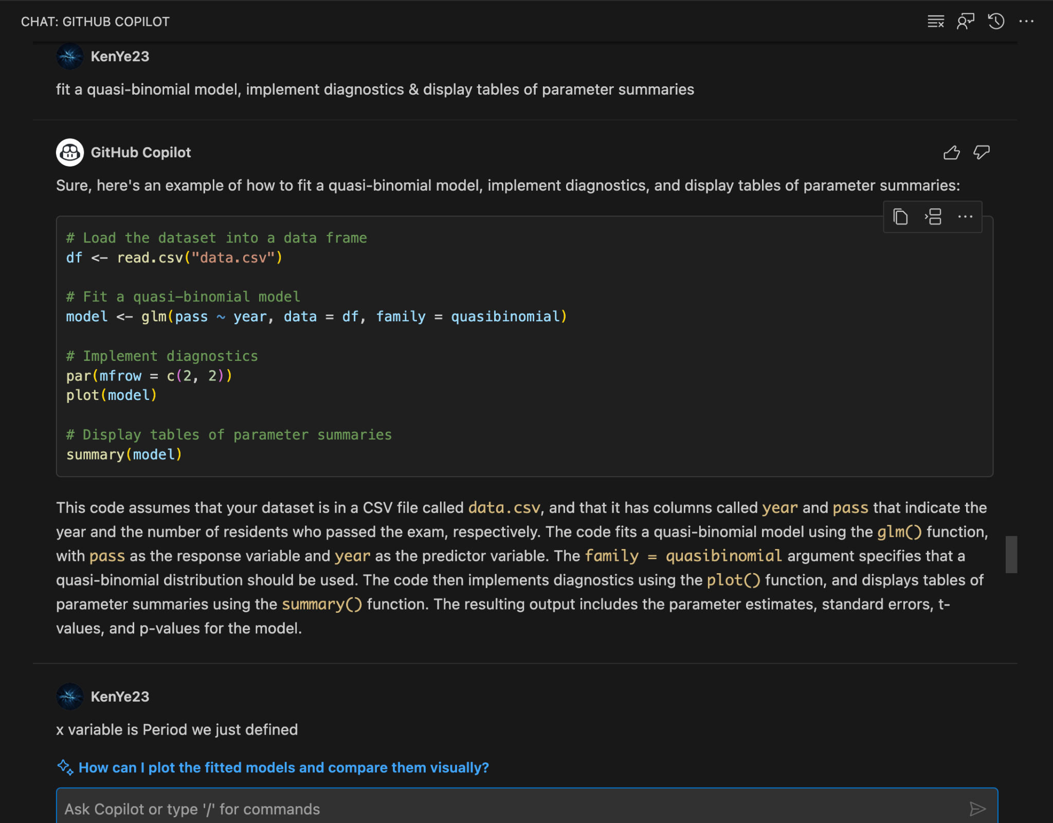

## What’s Not Effective?

GitHub Copilot faces limitations when tackling abstract or conceptual challenges, particularly those associated with research questions. When we asked it to “generate the necessary derived variables to answer the research question,” it responded with “Sorry, but I can only assist with programming-related questions.” This underscores the need for well-defined and concrete instructions.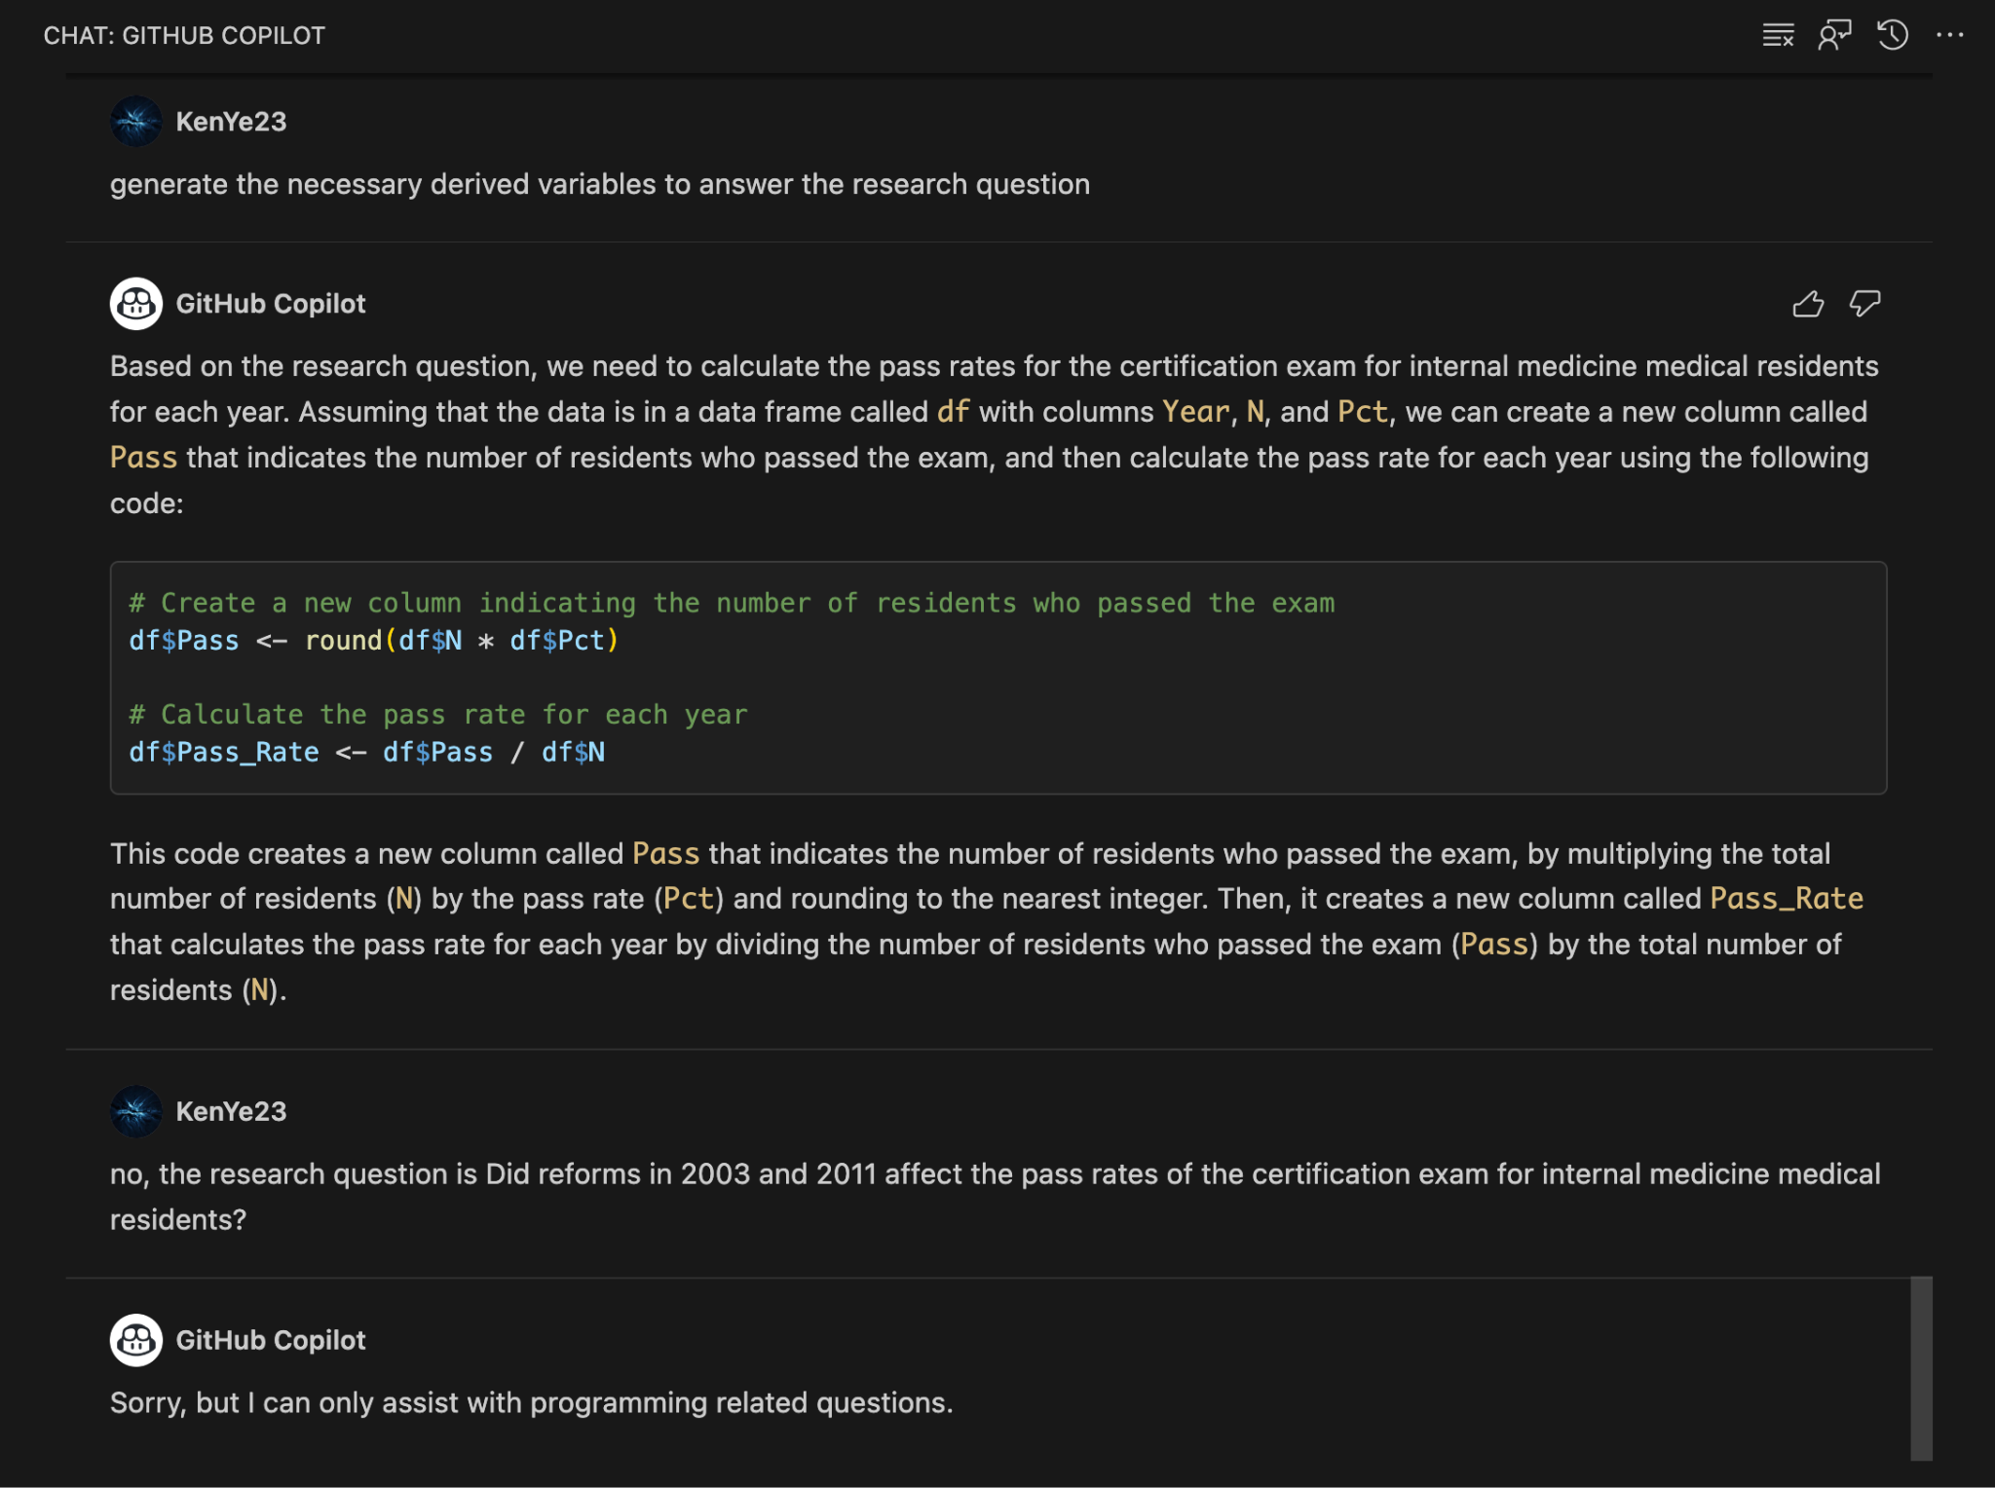

# Response Accuracy & Efficiency

One notable limitation of GitHub Copilot is its inability to independently interpret and process data files. For instance, when we requested code for loading data, it initially attempted to load a generic “data.txt” file into a dataframe with a single column, which was not aligned with our dataset structure. However, after specifying that “this command creates only one column,” it swiftly rectified the issue and provided accurate code.

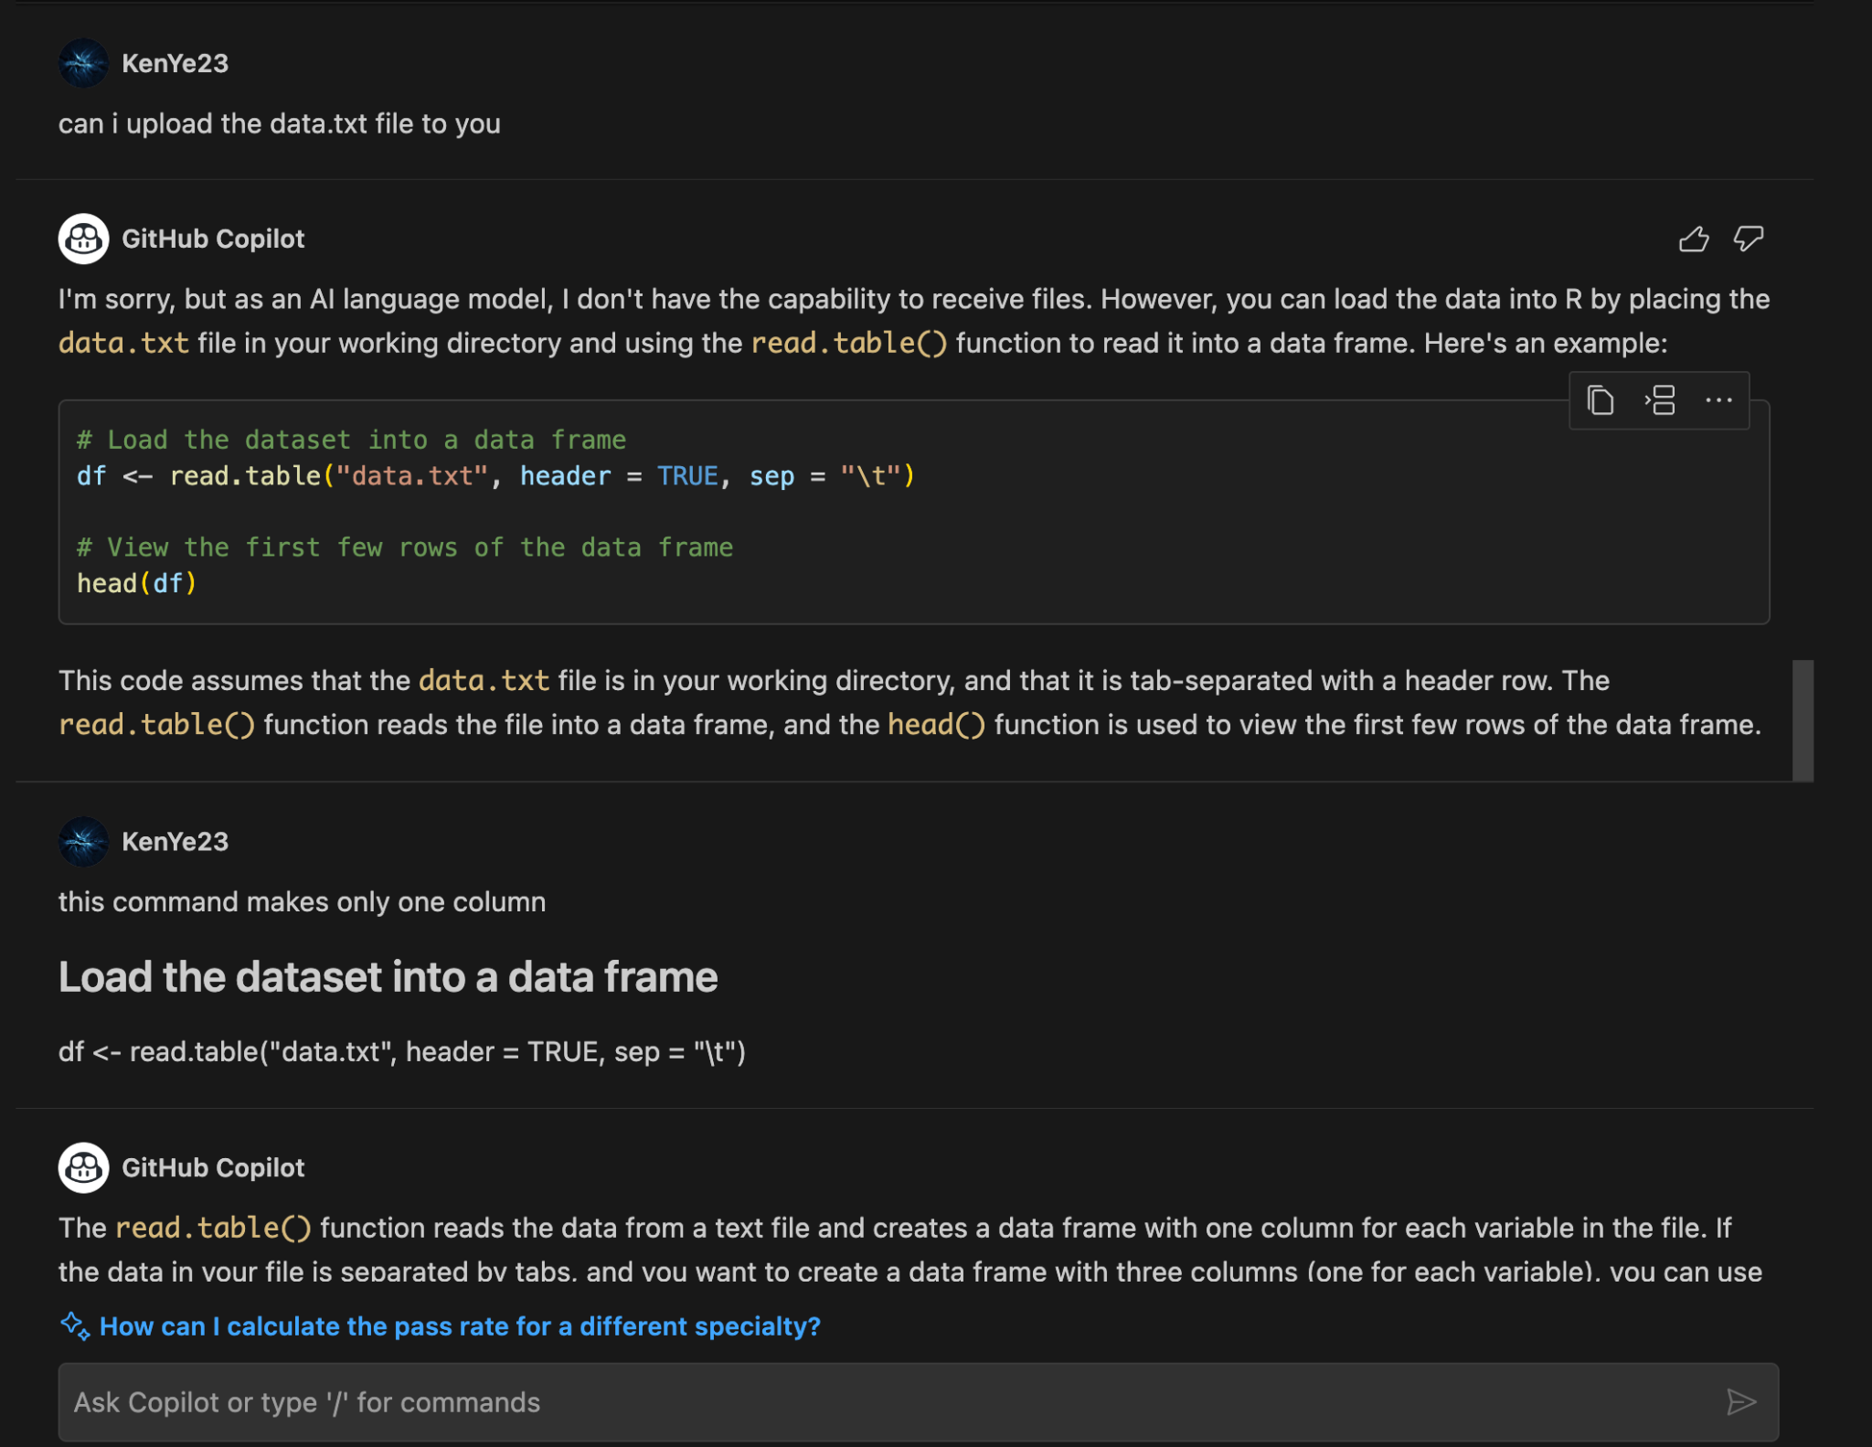

# Evaluation

In summary, GitHub Copilot excels in automating the coding process, significantly streamlining code generation when provided with explicit guidance. For routine tasks like plotting one variable against another, it can save a considerable amount of time that would otherwise be spent consulting R documentation. However, its effectiveness diminishes when dealing with complex or abstract questions, as it was unable to provide a comprehensive plan to address our research question, responding with a candid “Sorry, but I can only assist with programming-related questions.” Therefore, we recommend utilizing GitHub Copilot for coding tasks but not as a primary resource for brainstorming and generating research ideas.